Title: Security Operations Center (SOC) Lab Implementation using Wazuh SIEM

Submitted By: Kunj Brahmbhatt
Internship: CFSS Cybersecurity Internship
Domain: SOC Analyst & Blue Teaming
Duration: 4 weeks
Date:15th May 2026

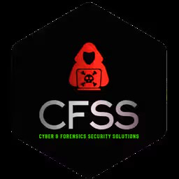

Executive Summary
This project involved the comprehensive design and implementation of a Security Operations Center (SOC) laboratory environment using the Wazuh Security Information and Event Management (SIEM) platform. The primary objective of this project was to develop a practical understanding of how modern cybersecurity operations are conducted, particularly focusing on real-time system monitoring, log analysis, and threat detection within a simulated environment.
The SOC lab was established using a virtualized infrastructure, where the Wazuh manager was deployed on a Linux-based virtual machine and integrated with a Windows endpoint through the installation of a Wazuh agent. This architecture enabled centralized log collection and analysis, providing visibility into various system-level and security-related activities occurring on the endpoint. The environment was configured to simulate real-world enterprise scenarios where continuous monitoring and rapid response are essential for maintaining system integrity and security.
Throughout the internship, multiple phases of SOC operations were carried out systematically. In the initial phase, the focus was on establishing a stable monitoring setup, ensuring that logs from the endpoint were being successfully transmitted to the Wazuh manager. Once the setup was completed, attention was shifted towards log monitoring and event analysis. Various system and security logs were observed and analysed in detail, including authentication events, process execution logs, and system-level activities. Special emphasis was placed on understanding Windows Security Event ID 4625, which represents failed login attempts, and interpreting its associated metadata such as user information, process details, and failure reasons.
In addition to authentication monitoring, the project also explored File Integrity Monitoring (FIM), where changes in system configuration and registry keys were detected and analysed. These observations highlighted the importance of tracking unauthorized or unexpected modifications within a system, as such changes may indicate potential security risks or malicious activity. The ability of Wazuh to detect and log these integrity changes demonstrated the effectiveness of SIEM tools in maintaining system visibility and control.
The next phase of the project focused on threat detection and simulation. Controlled attack scenarios were executed to replicate real-world security incidents. One such scenario involved multiple failed login attempts to simulate a brute-force attack pattern. These attempts were successfully detected by the Wazuh SIEM, which generated alerts based on predefined rules, confirming the system's capability to identify suspicious authentication behaviour. Furthermore, a malware simulation was conducted using the EICAR test file, a standard method used in cybersecurity testing. The system’s endpoint protection mechanisms detected and blocked the malicious file, demonstrating effective threat prevention even before full execution, thereby reinforcing the concept of layered security.
To enhance data interpretation and analysis, a custom dashboard was created within the Wazuh interface. This dashboard provided a visual representation of security data, including total alerts generated, authentication statistics, alert trends over time, and MITRE ATT&CK mappings. These visualizations enabled better understanding of system behaviour and assisted in identifying patterns and anomalies efficiently. The dashboard also highlighted how SOC analysts utilize data visualization tools to support decision-making and incident response processes in real-world environments.
Overall, this project successfully demonstrates the practical application of SIEM technology in a SOC environment. It provides hands-on experience in key areas such as log collection, event correlation, threat detection, and security data visualization. The knowledge and skills gained through this project reflect a strong foundational understanding of cybersecurity operations and emphasize the importance of proactive monitoring and analysis in protecting modern information systems.

Objective
- Build a SOC lab environment
- Monitor system and security logs
- Analyse authentication and system events
- Detect suspicious activities
- Simulate attacks and observe system response
- Visualize security data using dashboards

System Architecture

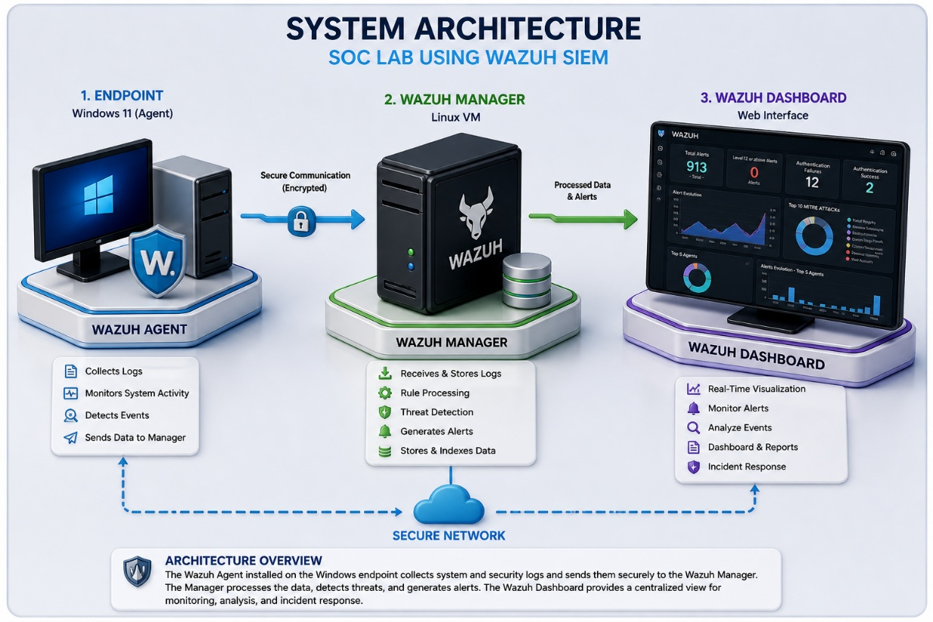
Figure: SOC Architecture using Wazuh SIEM

The architecture consists of a Windows endpoint with a Wazuh agent that collects system logs and sends them securely to the Wazuh Manager deployed on a Linux virtual machine. The manager processes logs, applies detection rules, and generates alerts. These alerts are visualized through the Wazuh Dashboard, enabling real-time monitoring and analysis in a SOC environment.

Tools
- Wazuh SIEM
- Oracle VirtualBox
- Windows 11
- Web Interface (Dashboard)

Implementation(Week Wise)
Week 1- Setup & Deployment
- In the initial phase, a virtualized SOC lab environment was established using Oracle VirtualBox. The Wazuh SIEM platform was deployed using a pre-configured OVA image on a Linux-based virtual machine. The Wazuh dashboard was accessed through a web interface to verify successful deployment.

- A Windows 11 system was configured as an endpoint, and the Wazuh agent was installed and connected to the Wazuh Manager using the manager’s IP address. Proper communication between the agent and manager was verified through the dashboard, ensuring that logs were being transmitted successfully.
Activities
- Installed Oracle VirtualBox
- Deployed Wazuh OVA (Linux VM)
- Accessed Wazuh Web Dashboard
- Installed Wazuh agent on Windows endpoint
- Connected agent to Wazuh Manager

Outcome:
- A fully functional SOC lab environment was successfully established, enabling real-time monitoring of the Windows endpoint.

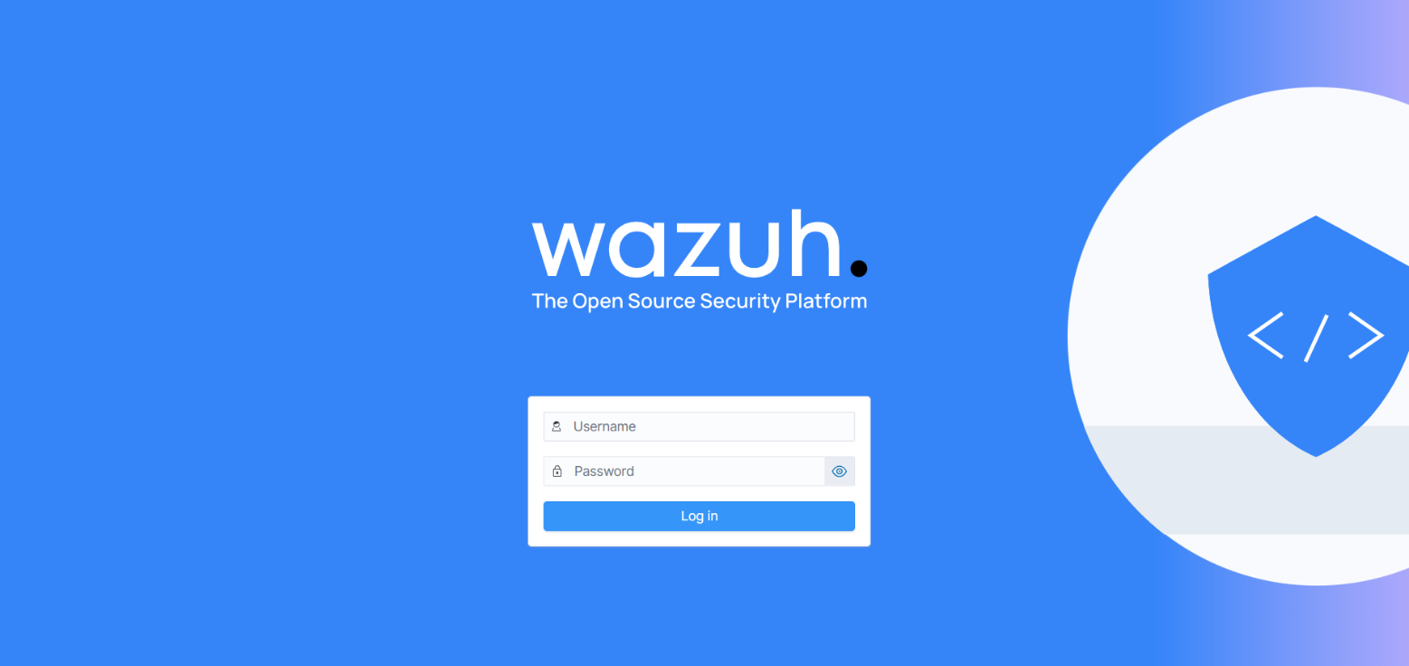
Figure 1: Wazuh Admin Login Page

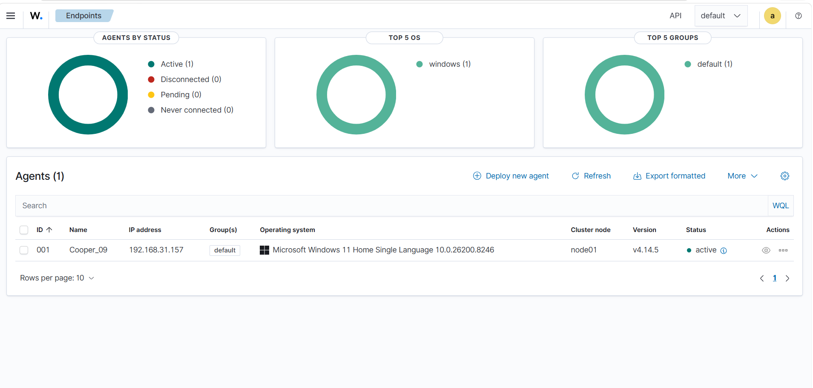
Figure 1.1: Wazuh Dashboard displaying active endpoint connection

Week 2- Log Monitoring & Analysis
- In this phase, the focus was on understanding how logs are generated, collected, and analysed within a SIEM system. Real-time monitoring was performed using the Wazuh Threat Hunting module. Various system and security logs were observed, particularly authentication-related events.

- Special attention was given to Windows Security Event ID 4625 (failed login attempts), where detailed event fields such as user identity, process name, logon type, and failure reason were analysed. Additionally, File Integrity Monitoring (FIM) was explored by observing registry key changes (Rule ID 594), which highlighted system-level monitoring capabilities.

Activities:
- Monitored real-time logs in Wazuh
- Analysed authentication events (Event ID 4625)
- Examined detailed event metadata
- Observed registry integrity alerts (Rule 594)

Outcome:
- Developed a strong understanding of log monitoring, event analysis, and how SIEM tools help in identifying unusual system behaviour.

Following Tasks:
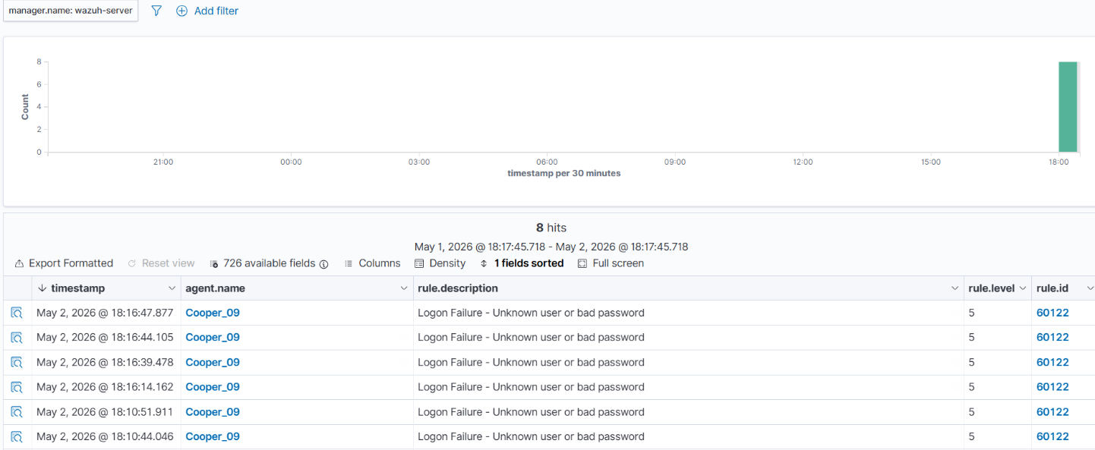
Figure 2: Authentication-related events observed in Wazuh (Event ID 4625)

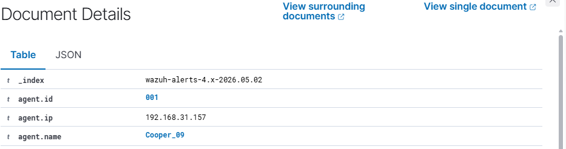
Figure 2.1: Detailed analysis of a security event showing logon failure information

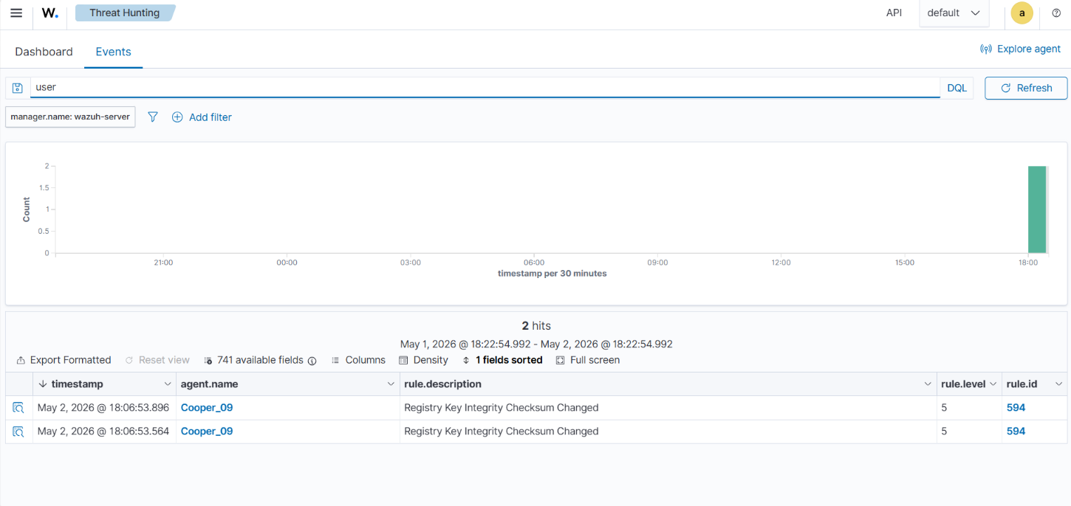
Figure 2.2: Registry integrity change detected using File Integrity Monitoring

Week3(Threat Detection & Simulation)
- This phase focused on simulating real-world attack scenarios and analysing the system’s response. Multiple failed login attempts were performed to simulate suspicious authentication behaviour. These activities were detected by Wazuh and logged as security alerts.
- Further analysis was conducted on alert patterns to understand how repeated events can indicate potential brute-force activity. Additionally, a malware simulation was performed using the EICAR test file. The endpoint security system successfully identified and blocked the file, demonstrating proactive threat prevention.

Activities:
- Simulated repeated failed login attempts
- Detected authentication anomalies
- Analysed alert patterns and frequency
- Performed malware simulation using EICAR
- Observed endpoint security blocking malicious file

Outcome:
- Successfully demonstrated the detection of suspicious activities and the effectiveness of endpoint protection mechanisms in preventing threats.

Following Tasks:
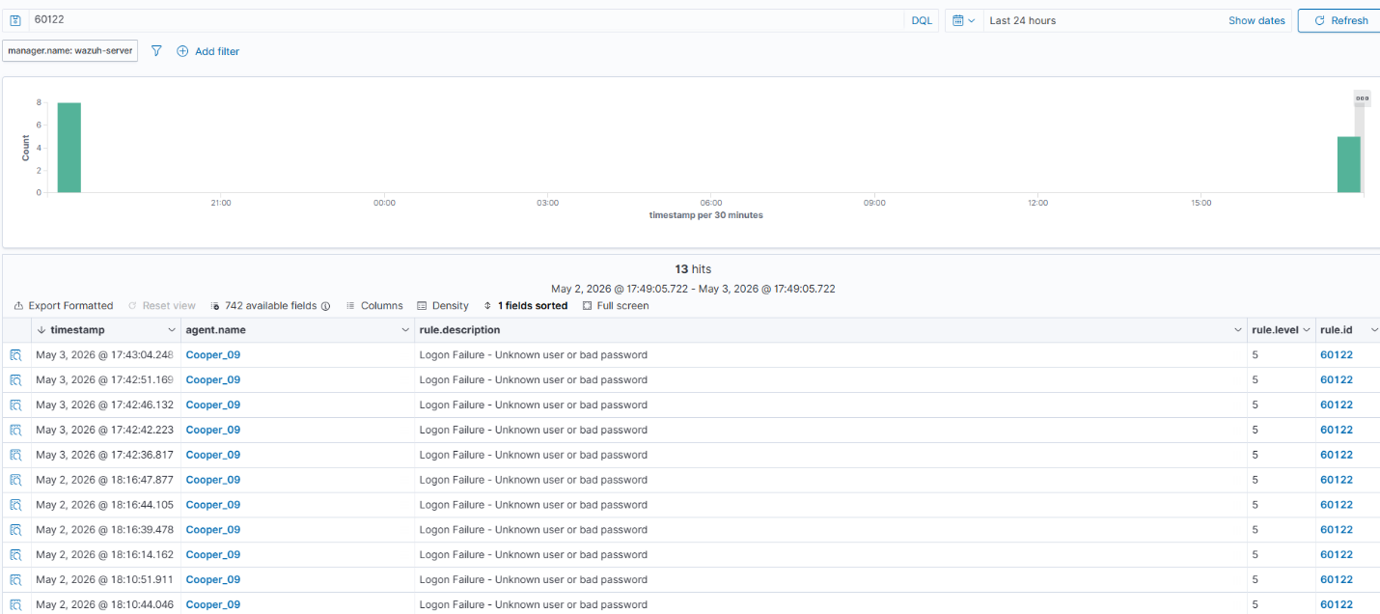
Figure 3.1: Detection of repeated failed login attempts indicating suspicious activity

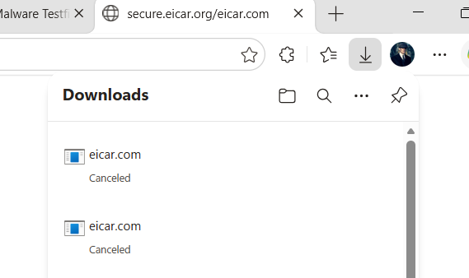
Figure 3.2: Malware simulation using EICAR test file blocked by endpoint security

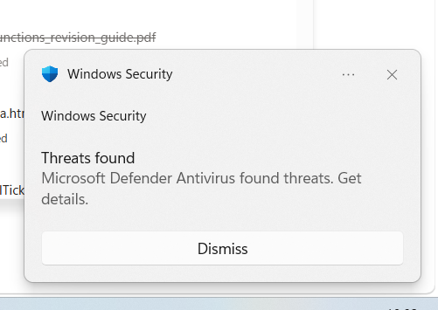
Figure 3.3: Malware Found and automatically blocked by security defender.

Week4(Dashboarding & Visualization)
- In the final phase, a custom dashboard was created to visualize collected security data. The dashboard provided insights into total alerts, authentication statistics, alert trends over time, and MITRE ATT&CK mappings.
- These visualizations helped in identifying patterns, understanding system behaviour, and improving overall threat analysis. The dashboard reflects how SOC analysts use data visualization tools for monitoring and decision-making.

Activities:
- Created custom dashboard in Wazuh
- Visualized alert trends and statistics
- Analysed authentication data
- Explored MITRE ATT&CK mapping
Outcomes:
- Developed the ability to present and interpret security data effectively using dashboards.

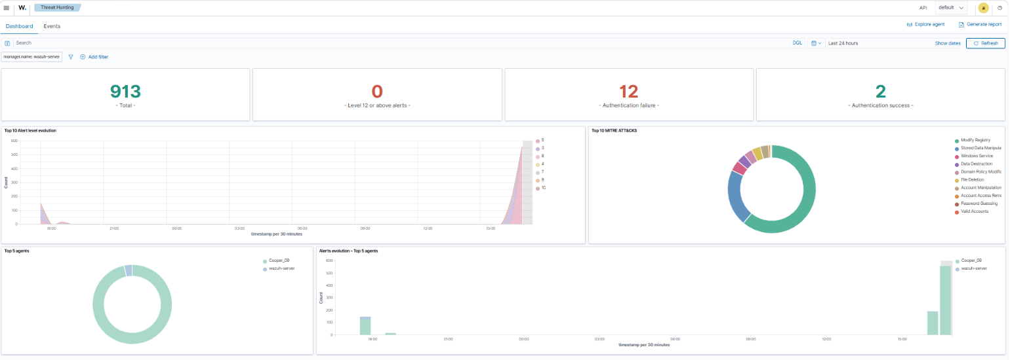
Figure 4: Final dashboard.

Result & Analysis:
- The system successfully detected authentication failures, monitored registry changes, and prevented malware execution.
- The dashboard provided clear insights into alert trends and system behaviour.
- Overall, the lab demonstrated effective log monitoring, threat detection, and data visualization.

Challenges faced:
- Difficulty in agent connection initially
- Malware detection not always visible due to instant blocking
- Understanding raw logs and event data
These challenges helped in improving troubleshooting and analytical skills.

Conclusion:
- This project provided valuable hands-on experience in Security Operations Center (SOC) activities including system monitoring, log analysis, threat detection, and dashboard visualization using Wazuh SIEM.
- Through multiple practical simulations and real-time monitoring exercises, the project demonstrated how SIEM platforms are used to identify suspicious activities and improve security visibility in modern environments.
- Overall, the internship enhanced technical understanding of cybersecurity operations and strengthened analytical and troubleshooting skills required in SOC environments

